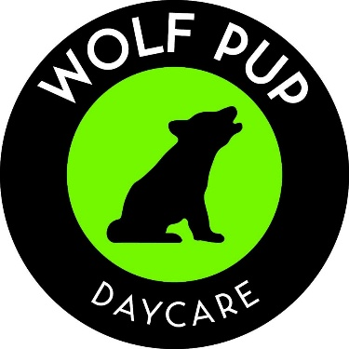

Wolf Pup Daycare
Weekly Program Rates
Effective August 2026

Daycare Programs – weekly rates
- All Programs include meals (breakfast, lunch and snacks), formula (Members Mark Advantage), baby purees and rice/oatmeal cereal.

Age | Weekly
Full time daycare for 0 – 18 months | $293.55
Full time daycare for 19 – 35 months | $278.10
Full time daycare for 3 year olds | $267.80
Full time daycare for 4 & 5 year olds | $257.50
Part time daycare for 0 – 24 months | $82.40/day
Part time daycare for 2 & 3 year olds | $72.10/day
Part time daycare for 4 & 5 year olds | $66.95/day
Drop – In (0-5) | $82.40/day
Yearly supply fee | $75

