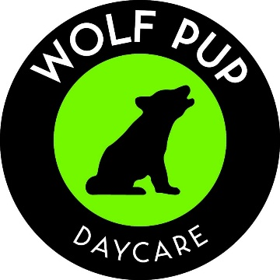

Wolf Pup Learning Center
Monthly Program Rates
Effective August 2026

Program Information
- Hours of Operation: Monday – Friday: 8:30 – 11:30 am; 12:00 – 3:00 pm
- Rates Include: AM snack for morning session and PM snack for afternoon session
- Registration Fee (non – refundable): $150.00 per child

Learning Center Programs – monthly rates
Weekly Attendance | Monthly
Part time (TTH) | $175.10
Part time (MWF) | $257.50
Full time ( 5 days) | $298.70

